Microelectronics Research Laboratory(MRL):

Microelectronics Research Laboratory is engaged a variety of Research Areas for the development of Devices and Circuits for present and future. The laboratory started in 1980s with $5 million dollar investment with a private company. More than 80 students have obtained Ph.D.’s with the work going on the laboratory. The research work going on in the laboratory has resulted hundreds of publications in international journals and conferences with over ten thousand citations in technical literature. Students graduated from our group are working in companies such as Intel, Qualcom, Broadcom and Infineon technologies. In addition, we partner with small companies in SBIR and STTR projects. Recently, Symetrix Corporation has donated over $1million dollar to upgrade the facility to process 12” wafers.
Contact persons for MRL:
Professor T.S. Kalkur, Chair, Dept. of ECE, UCCS, tkalkur@uccs.edu or
Bogdan Crivin, Lab Manager, bcrivin@uccs.edu
The following are the current Research Projects:
- Tunable devices for RF circuits:
- Single ended and differential Tunable filters with BST capacitors.
- Tunable capacitor based line drivers for communication.
- Switchable and tunable resonators, duplexers and filters.
- BST capacitor based voltage controlled oscillators and phase locked loops.
- Tunable multiband antennas.
- Tunable multiband amplifiers.
- SAW based Torque sensors
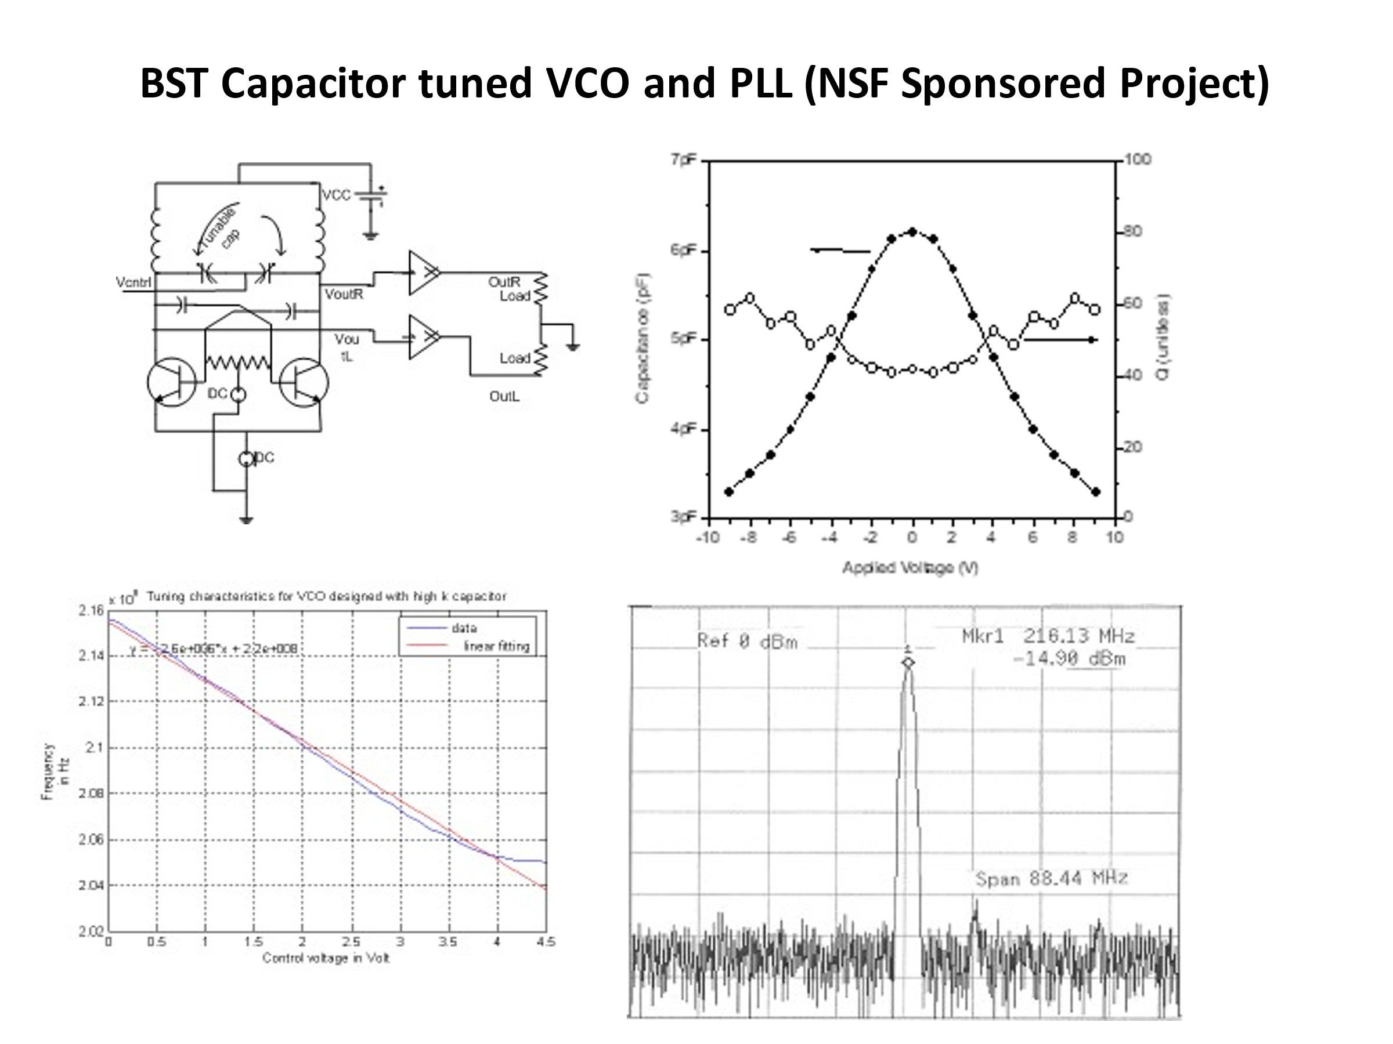
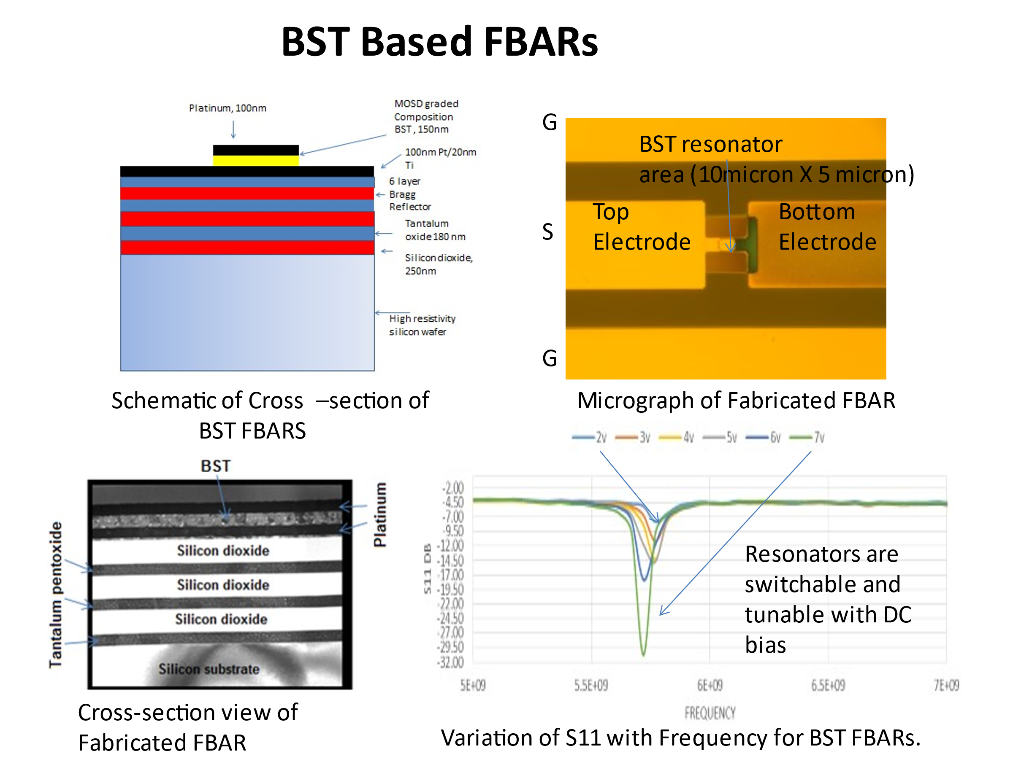
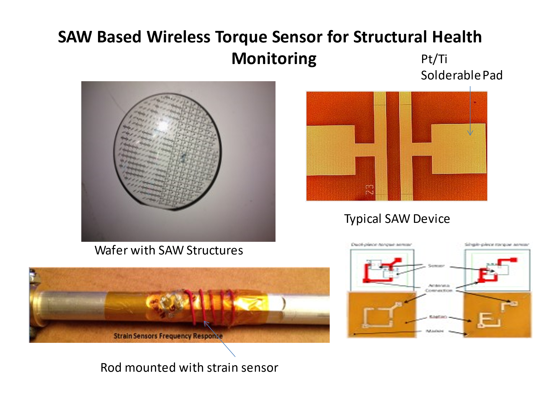

Non-volatile memory devices:
- Ferroelectric gate based Field Effect Transistors.
- Switching resistor based memories.
- Nano-crystal based memories
- Polarization switching Digital to Analog Converters.

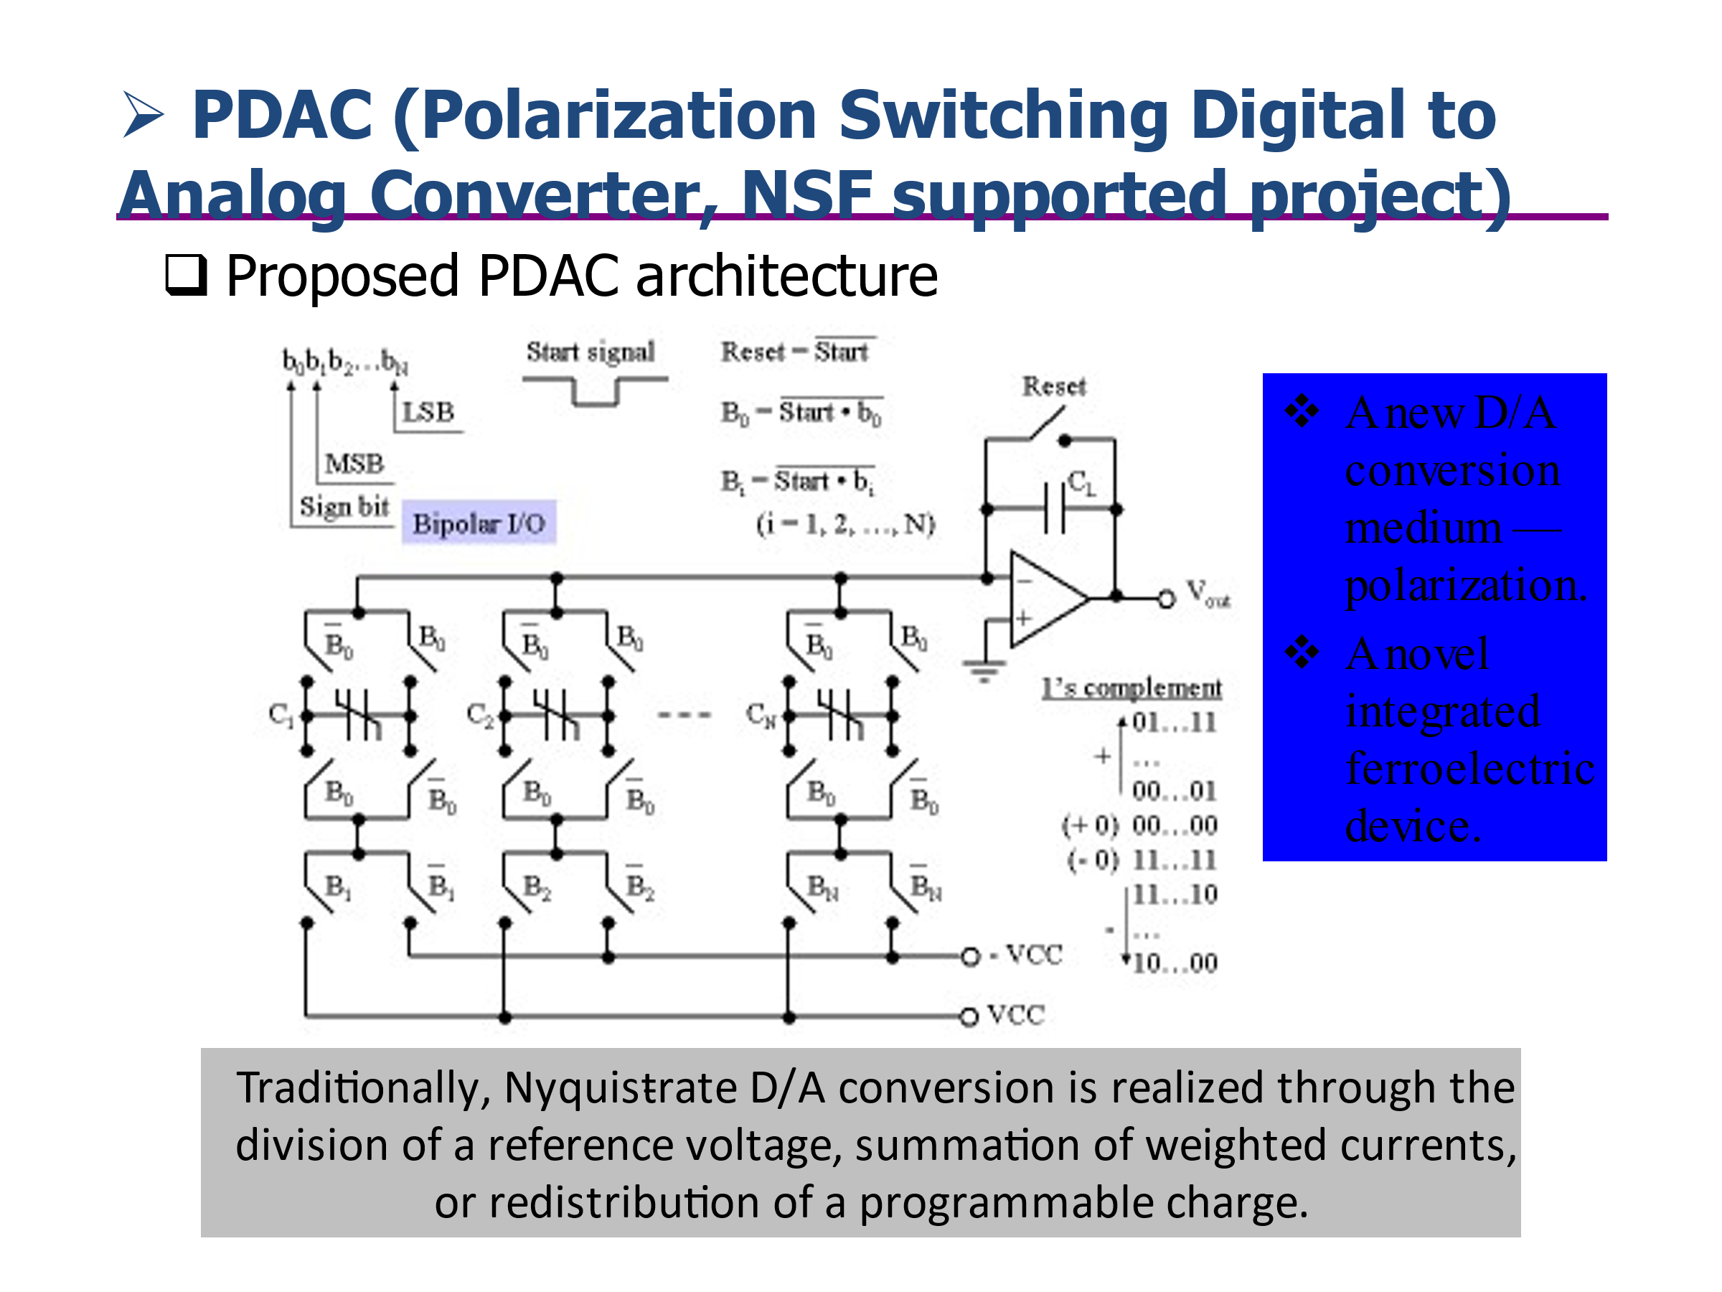

- Microelectromechanical Devices.
- Power device packaging and heat spreading techniques.
- Study of diamond based epoxy for packaging applications.
- Characterization of diamond-epoxy composites for high frequency packaging
With improved power dissipation.
Facilities: MRL is equipped with device processing and characterization. This includes 4000 sq.ft class 100 clean room with the following processing capabilities:
- Furnaces to grow wet and dry oxide on silicon, perform boron and phosphorous diffusion and annealing on 4” silicon wafers.
- Rapid thermal annealing system.
- Siebert DC magnetron sputtering system for the deposition of metals.
- Mask aligner: OAI and Karl-Suss for aligning patterns on 4”wafers.
- Plasma ashing system.
- Atmospheric plasma cleaning system.
- Ion mill to etch patterns on small size samples to 12” diameter wafers.
- Dektak Profilometer, computerized ellipsometer.
- Microscopes for optical characterization.
- Rapid prototyping machine for the fabrication of devices.
Device Characterization Facility
- Probe station with hot chuck and micromanipulators.
- Micro-soldering station.
- LCR meter, pico-ammeter, programmable power supply, and 4146 Parametric anayzer
- Keysight Vector Network Analyzer, 45MHz-45 GHz with ECAL.
- Keysight 30 MHz Impedance Analyzer.
- Keysight 45GHz Spectrum Analyzer with Phase Noise Measurement module.
- Keysight 50GHz RF source
- Probe station with Cascade Microprobe for on-wafer characterization.
- K and S manual wire bonder.

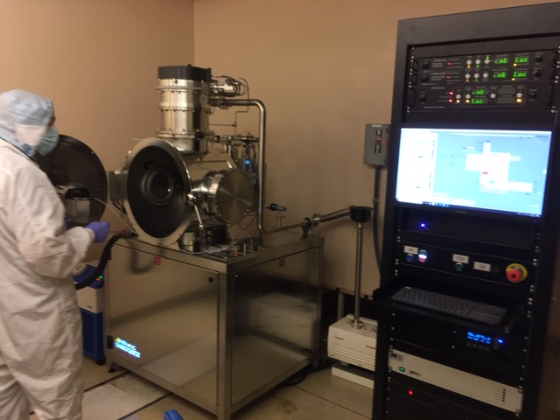
Ion Milling system to etch fine patterns

